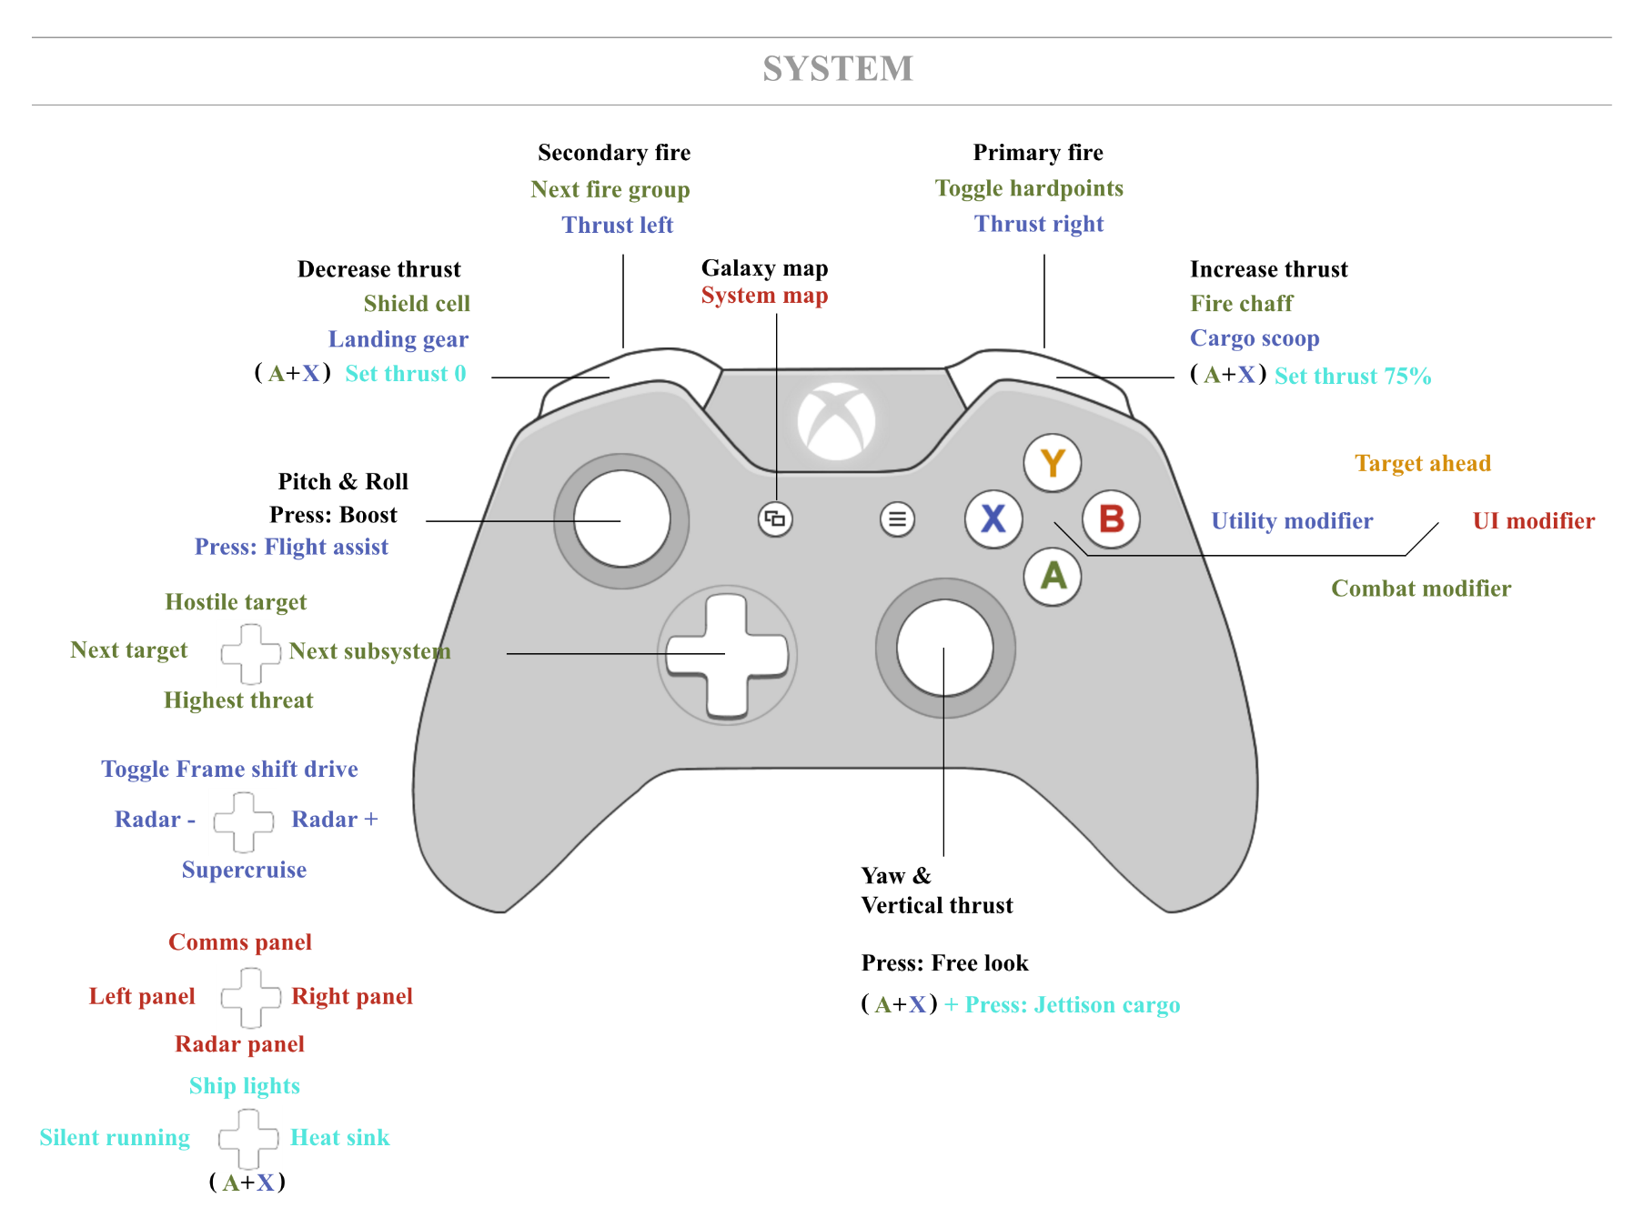
System

Combat
UI
Utilities

Dahkron’s Elite Dangerous Xbox-Bind ( https://github.com/cmdrdahkron/elite-binds/ )

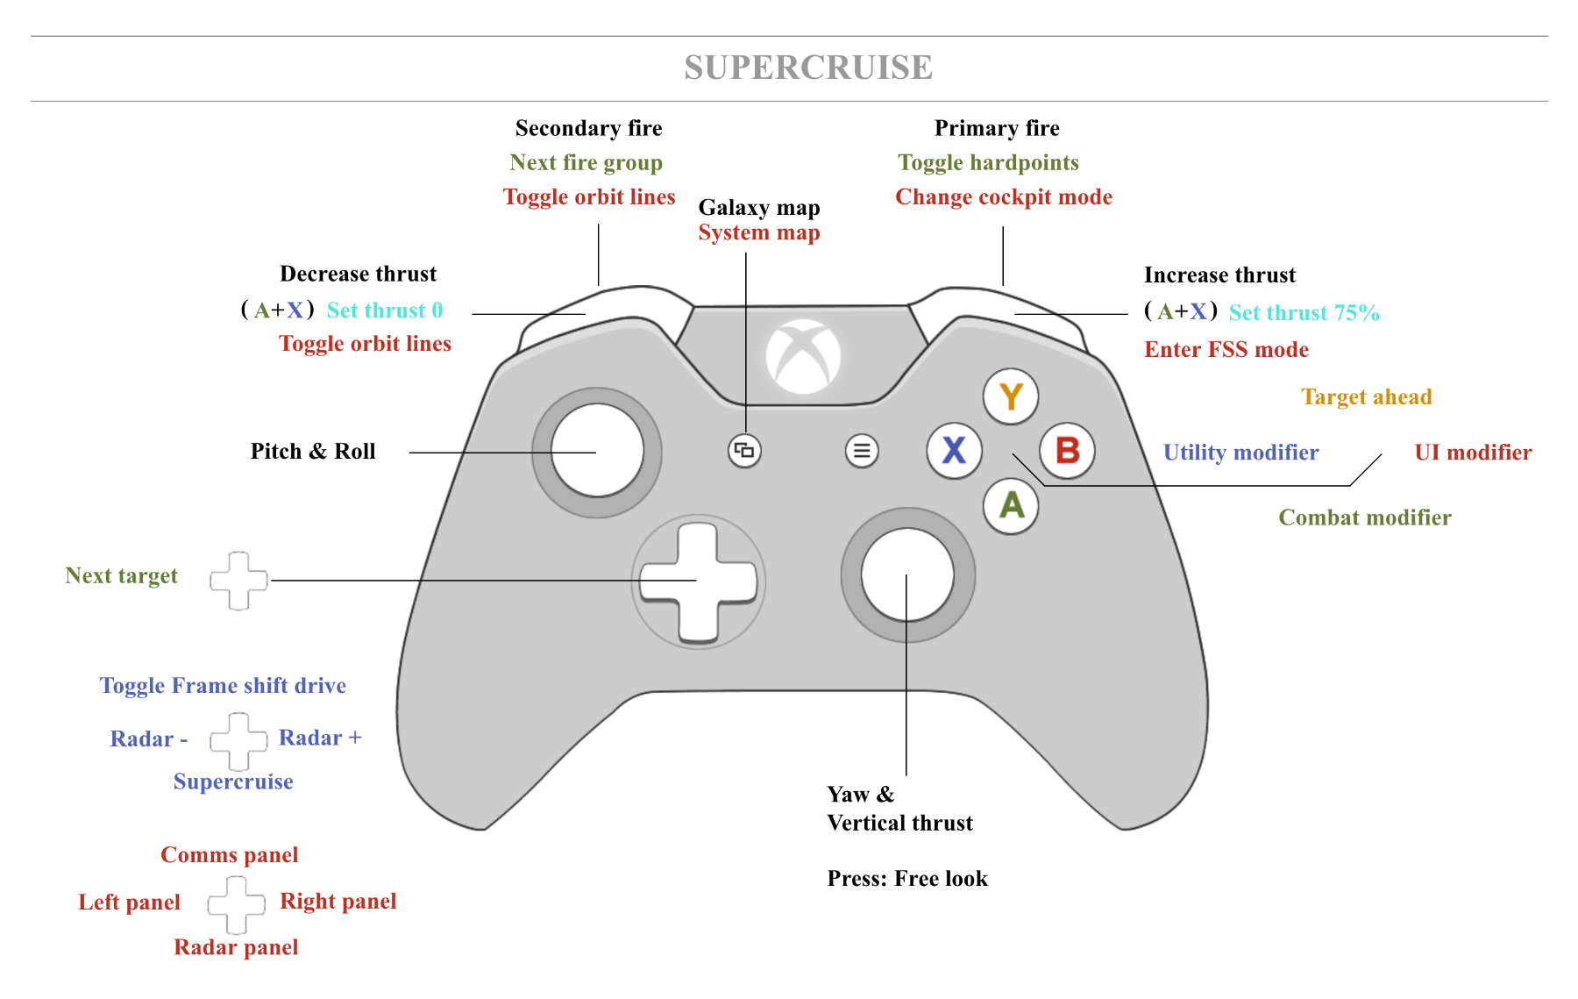
Super Cruise

Landing (includes and overrides system)
Dahkron’s Elite Dangerous Xbox-Bind ( https://github.com/cmdrdahkron/elite-binds/ )
Combat
UI
Utilities

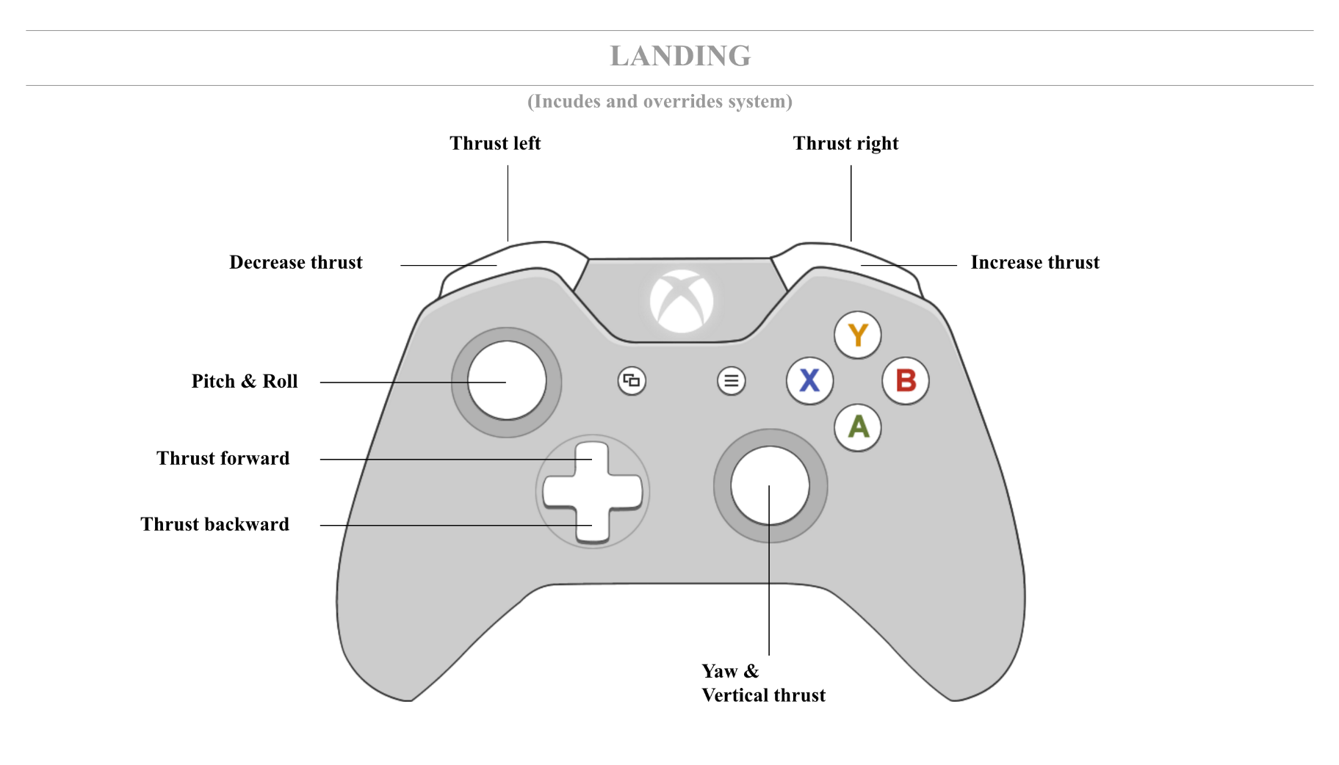

Combat
UI
Utilities

Dahkron’s Elite Dangerous Xbox-Bind ( https://github.com/cmdrdahkron/elite-binds/ )

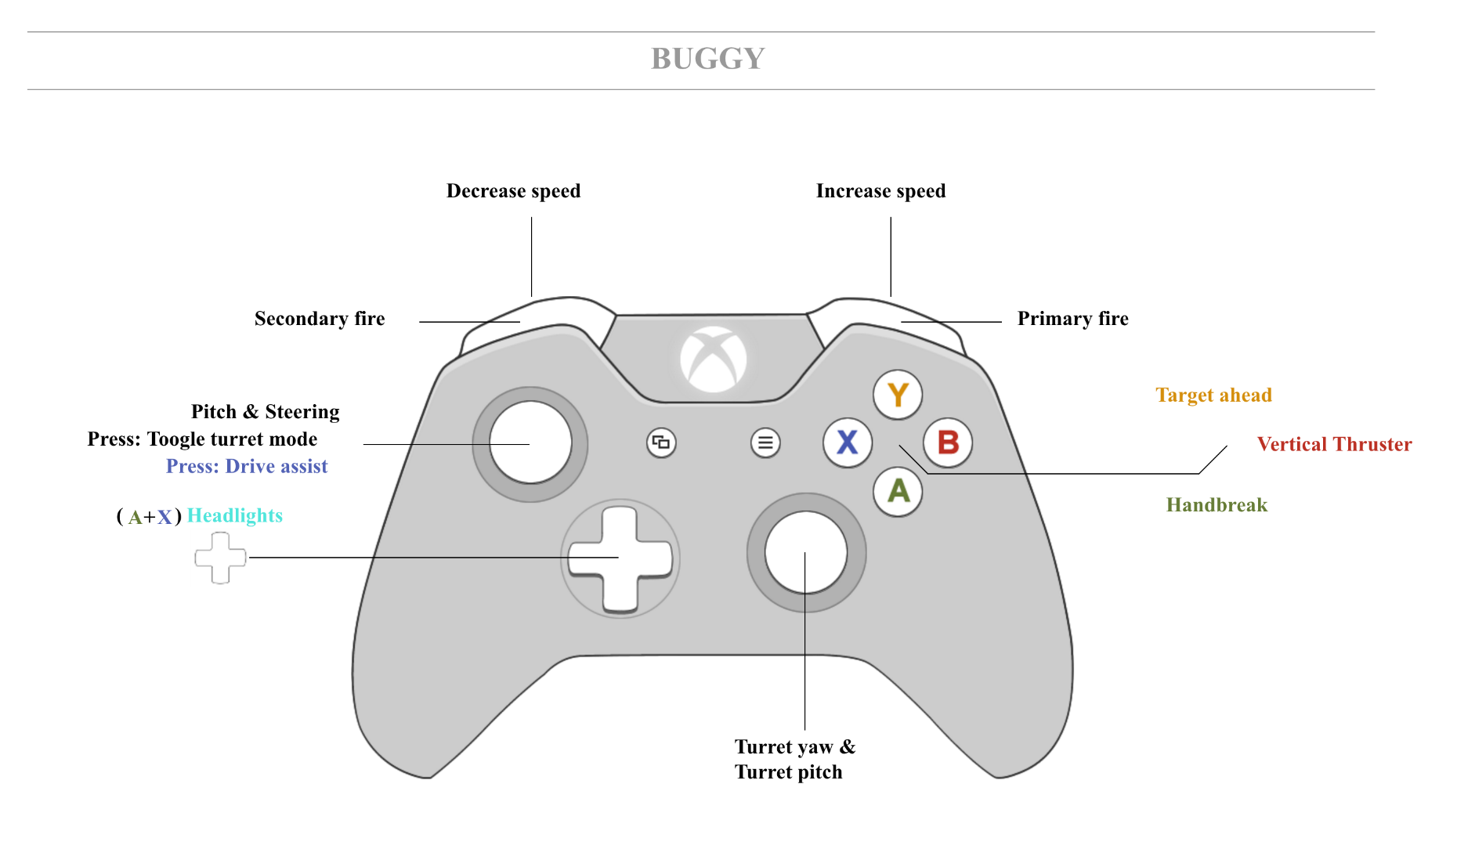
Buggy

Combat
UI
Utilities

Dahkron’s Elite Dangerous Xbox-Bind ( https://github.com/cmdrdahkron/elite-binds/ )
FSS
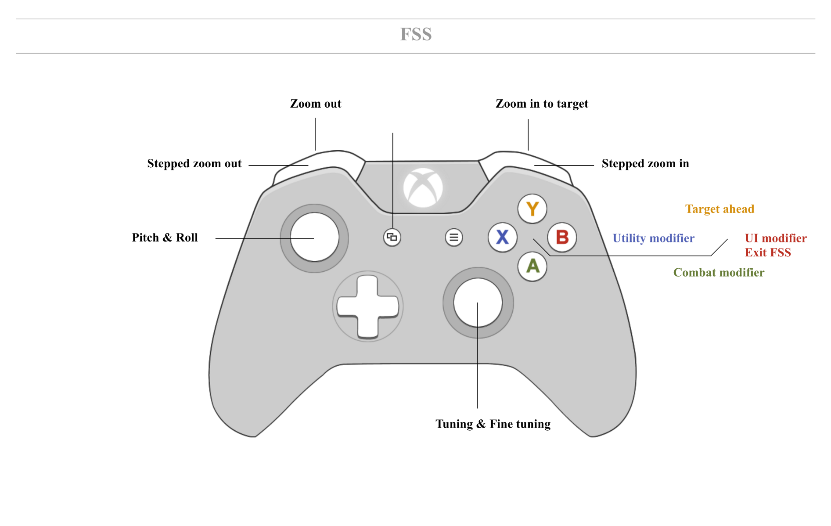

Dahkron’s Elite Dangerous Xbox-Bind ( https://github.com/cmdrdahkron/elite-binds/ )
Combat
UI
Utilities

